Castlebay Culmination Information - 2019
g

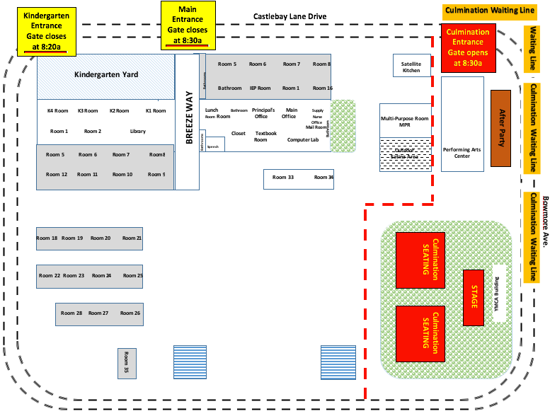
- The Kindergarten culmination and TK celebration are Wednesday, June 5, 2019 @ 8:30 am at Castlebay Lane Charter Elementary School.
- CLOSED CAMPUS: We will have a closed campus that morning.
  - All 1st – 5th grade students (no parents) will enter through the main gate at the front of the school.
  - All Kindergarten and TK students will enter through the kindergarten gate by 8:10am. TK parents will wait on the yard (approximately 10 minutes) while the children get ready.
  - The main gate will be locked at 8:30a. The kindergarten gate will be locked at 8:15a.
  - All late students MUST enter campus through the main office after the gates are closed.
  - All TK and kindergarten students MUST be at Castlebay by 8:10 am on the day of culmination to prepare.
- PARKING: Parking on campus or in the staff parking lot is prohibited.
  - Police will enforce all driving and parking laws
- SEATING: At 7:50 am the main gates will open to allow seating for the kindergarten culmination on the grass field.
  - Parents may accompany their children in the morning and proceed through the classrooms to the grassy area to find seats.
  - The front row is reserved for Castlebay staff.
  - Seating is on a first-come first-serve basis. Seats may not be reserved.
  - Only the PAC bathroom will be open for adult use.
- Ceremony will begin promptly at 8:30am.
- Balloons and large flower arrangements will not be allowed on campus as they impede spectator view. Please leave balloons and flowers in the car
- Refreshments will be served at 9:00 am in the kindergarten yard.
- If parents would like to take their kindergartner or TK child from school early to continue the celebration, they must sign the roster that each kindergarten teacher will have in their classroom. Dismissal for those remaining at school will be 12:44 p.m.
- The remainder of the week will be early dismissal at 12:44 p.m. on Thursday and Friday. Friday is the last day of school!

